Data Sheet

Labclave-L Models
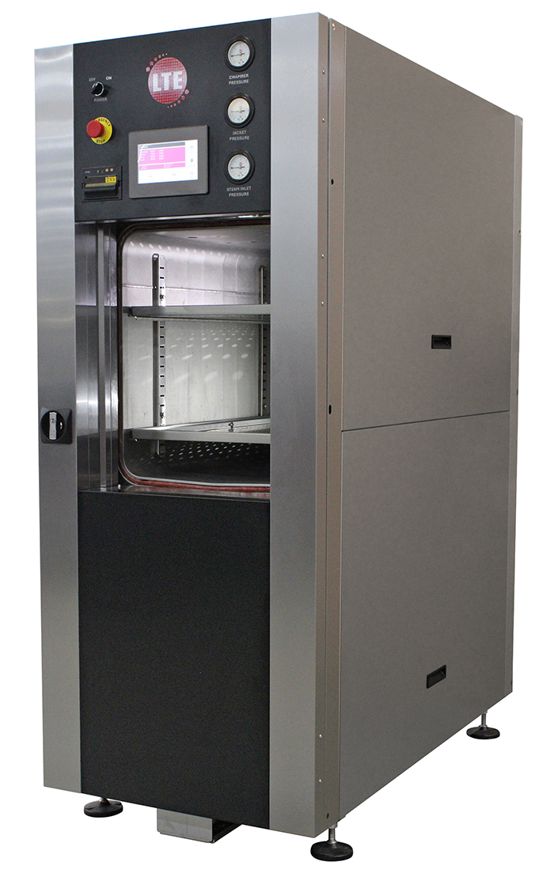
Standard Range Features
- Rectangular Chamber
- Easy-glide vertical sliding door
- Integral steam generator or direct steam options
- Water jacket cooling
- Up to 20-program touchscreen control system
- Internal data archiving for up to 20000 cycles
- Individual PIN codes for traceability
- Fully self-contained
- Small footprint

Capacity | 150, 225, 300, 360 and 450 litres
Vessel Type | Rectangular Section, jacketed
Vessel Dimensions, mm | 600 x 500 x 515/745/1000 HWD (150/225/300-litre)  700 x 670 x 765/965 HWD (360/450-litre)
Shelves/Positions | 15-20 available positions dependant on vessel size
Pressure Vessel Material | High grade 316 stainless steel
Pressure Vessel Finish | Glass bead finish (RA value 2.5µm)
Pressure Vessel Compliance | Pressure Equipment Directive 97/23/EC and independently certified to PD5500:2000 Cat. 3
Other Applicable Standards | BS3970 / BS2646 / HTM2010 (Optional)
Door Type | Easy-glide vertical sliding door
Door Seal | Floating
Steam Source | Integral steam generator or Direct Steam
Temp. Range, ˚C | 105-140
Pressure Range | Zero (or 50 mbarA if vacuum fitted) to 3.1bar
Overall Dimensions, mm | See brochure for details
Control System | Up to 20-program touch-screen system.
Data Archiving | Internal flash-card system (up to 20 000 cycles)
Standard Cycle Features | Timed auto-start; batch no. input; operator ID
Silent Air Compressor | Included
Cooling Method | Water jacket cooling
The above is the standard specification. Any modification/deviation for the above will be clearly identified on the quotation front sheet.

